


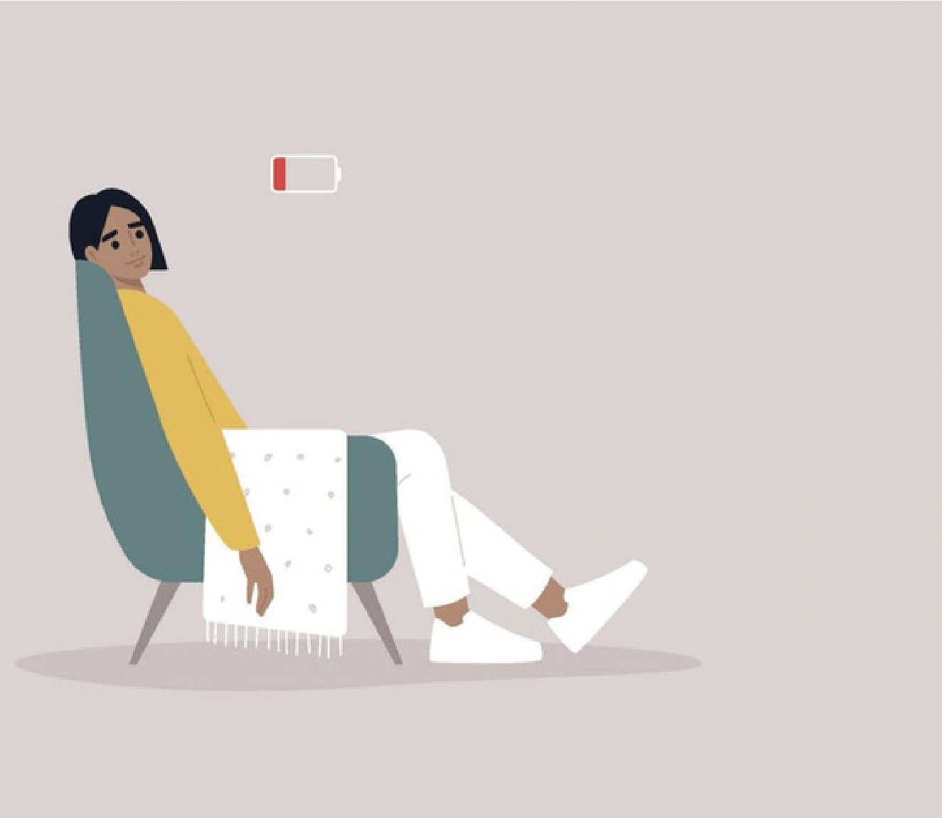

RECHARGE

Do you still feel drained no matter how much sleep you get?
Learn about the 7 types of rest and
what you can do to boost and maintain energy.

Employees who attend a presentation will receive a workbook to design a personal recharge plan.

For more information, visit us at
www.commonhealth.virginia.gov,
and follow us on social media:

Where:
When:
[INSERT LOCATION/ROOM HERE]
[INSERT DATE AND TIME HERE]

